**Dr. Katie Sagal Office: South Hall 208**

**asagal@cornellcollege.edu / x4584 Office Hours: By appointment**

**M-F, 9-11:30 / Block 1 Cole Library, Room 216**

**ENG 319 – Advanced Critical Writing**

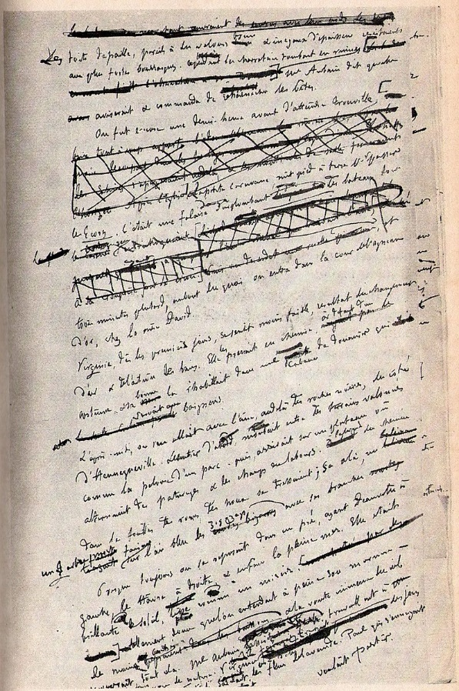Writing is a process that spans nearly every area of our lives – not just the academic classroom. You write when you send a text, an e-mail, a tweet. You write when you make a grocery list, a playlist, or a to-do list. You’ve written your application materials to come to Cornell, and many of you will write materials for graduate school applications; all of you at some point will write different types of documents to apply for a job, such a resume or curriculum vitae. What unites each of these genres is not the mere fact that you are committing the act of writing, but that each of these pieces of writing require a knowledge of context, media, and aims to successfully make it out in the world.

This is where being a writer-researcher comes in. In this class, I don’t want you just to think of writing that something happens divorced of all context, or, conversely, something that can have an overwhelming number of potential contexts. In balancing the ideas of writing with appropriately and successfully conducting the research needed to make that piece of writing do the job it’s meant to do, we will further develop not only your writing skills but your critical thinking skills as well.

In nuancing your skills as a writer-researcher in this course, you will produce multiple pieces of in-progress and polished pieces of writing (although I would argue that no piece of writing is ever truly perfect). We will complement our daily writing sessions with small-group work, selected inspirational readings, and individual meetings with me. Because this is an upper-level class and many of you are coming from different disicplinary backgrounds and interests, much of the content of what you write will be self-directed; I provide only certain pieces of reading to help motivate you and spark discussion.

**Course Texts (Available at the Bookstore)**

*Academic Writing, Real World Topics* (Broadview: ISBN 9781554813308)  
*The Broadview Pocket Guide to Writing* (Broadview: ISBN 9781554813445) – for reference

# **Course Goals**

* To practice writing – every day.
* To refine technical writing skills such as spelling, punctuation, and grammar.
* To develop an individual writing style.
* To cultivate advanced research and writing skills that will prepare you for professional or graduate-level work.
* To develop cultural literacy and the ability to think across cultures.
* To engage in ethical research and documentation practices.

# **Educational Priorities**

* **Knowledge:** integrate and apply knowledge from a focused area of study as well as a broad general education which includes disciplinary and interdisciplinary perspectives in the arts, humanities, sciences, and social sciences.
* **Inquiry:** respond to the complexities of contemporary and enduring problems using information literacy tools, research skills, creative thinking, and analysis.
* **Communication:** speak and write clearly, listen and read actively, and engage with others in productive dialogue.

*This course supports the Educational Priorities and Outcomes of Cornell College with emphases on knowledge, inquiry, and communication.*

# **Course Policies**

## **Preparation & Attendance**

Come to class prepared to fully particpate in all discussions and activities. I understand that not everyone is comfortable speaking frequently in class, but in such a small classroom environment it is to everyone’s benefit if we all contribute at least once in a while. Please bring all assigned readings to class on the day we will be discussing them so that you can refer to them while we talk. More than four absences from class meetings, individual meetings, or workshops may result in failure of the course. We will usually meet in the mornings as a class, and then allow for individual writing time in the afternoon. This will occasionally be in the classroom, and occasionally on your own.

## **Computers & Technology**

You should plan to bring your computer to class most days, as we will spend time writing in class during most meetings. Please do not use your computer during class time for anything unrelated to class work or research. Turn your cellphone on vibrate and do not text or take calls except in case of emergency.

## **Assignments**

Unless otherwise stated, assignments are due at the beginning of class (9 am). Please print all assignments (double-sided will save you paper) and turn in hard copies unless I have specifically asked you to turn them in via Moodle; I do not want you to e-mail me assignments unless we have discussed this as a case-specific alternative. Staple or paper-clip all assignments of more than one page; I may be mercurial and not accept a random stack of pages. Put your name on the front page of each assignment.

## **Academic Honesty**

Cornell College expects all members of the Cornell community to act with academic integrity. An important aspect of academic integrity is respecting the work of others. A student is expected to explicitly acknowledge ideas, claims, observations, or data of others, unless generally known. When a piece of work is submitted for credit, a student is asserting that the submission is her or his work unless there is a citation of a specific source. If there is no appropriate acknowledgement of sources, whether intended or not, this may constitute a violation of the College’s requirement for honesty in academic work and may be treated as a case of academic dishonesty. The procedures regarding how the College deals with cases of academic dishonesty appear in The Catalogue, under the heading “Academic Honesty.” (<http://www.cornellcollege.edu/student_affairs/compass/academicpolicies.shtml>).

**Accommodations**Cornell College makes reasonable accommodations for persons with disabilities. Students should notify the Coordinator of Academic Support and Advising and their course instructor of any disability related accommodations within the first three days of the term for which the accommodations are required, due to the fast pace of the block format. For more information on the documentation required to establish the need for accommodations and the process of requesting the accommodations, see <http://www.cornellcollege.edu/academic-support-and-advising/disabilities/index.shtml>

## **Extensions & Due Dates**

I expect that you will turn in every assignment on the indicated due date on the course calendar, at the beginning of the class meeting. If you are unable to attend class for an excused reason (religious observation, sporting event, etc.), you should plan to turn the assignment in early. I am, however, also willing to be flexible and talk with you about your unique circumstances, so please, *talk to me first* if you feel you will be unable to make a certain deadline – turning in a paper or other assignment late without talking to me first will result in a deduction in your grade. For every day late on a major assignment, I will deduct one full letter grade from the grade it would have earned. For example, if you write a B+ paper, but turn that paper in one day late, I will give you a grade of C+.

## **Grading**

Your final grade in this class will be determined by a number of assignments, completed sequentially throughout the semester. I *may* offer extra credit about mid-block. I will provide grading rubrics for each assignment explaining my criteria for that particular piece of writing.

The break-down of your final grade is as follows:

Class Participation & Readings 10%  
Annotated Bibliography 20%  
Personal Statement 15%  
Grant Proposal 10%  
Open-Topic Essay 15%   
Major Revision 20%   
Conference Paper 10%

EPO: Each of these assignments emphasizes the educational priorities of inquiry and communication; the annotated bibliography, open-topic essay, conference paper, and major revision all emphasize the eudcational priority of knowledge as well.

## **Contact Me**

I will hold office hours by appointment only, or you can catch me after class to chat. I encourage you to get in touch with me early in the block if you’re having any concerns, difficulties, or questions, or if you just want to chat. I can be reached at my college e-mail ([asagal@cornellcollege.com](mailto:asagal@cornellcollege.com)) until about 8 pm at night, and after about 8 am in the morning. I do not regularly check my e-mail between 8 pm – 8 am.

# **Course Calendar**

## **Day 1: Monday 8/27**

Course introduction; syllabus overview  
Discussion of revision goals; write cover letter for essay to be revised and post to Moodle  
Read in class and discuss “Approaches to Style” (Moodle)

## **Day 2: Tuesday 8/28**

Discussion of “Audience” & “Narrative Perspective” (AWRWT)  
Annotated Bibliography Workshop  
Write for one hour

## **Day 3: Wednesday 8/29**

Discussion of “Evidence” and “Appeals” (AWRWT)  
Personal Statement Workshop  
Write for one hour

## **Day 4: Thursday 8/30**

Discussion of “Mapping” and “Essay Body” (AWRWT)  
Practice essay mapping in class  
Write for one hour

## **Day 5: Friday 8/31**

Discussion of “The Introduction” and “The Conclusion” (AWRWT)  
Personal Statement due (~700 words)  
Write for one hour

## **Day 6: Monday 9/3**

Discussion of “Integrating Sources” (Moodle)  
Guided library research time  
Write for one and a half hours

## **Day 7: Tuesday 9/4**

Open Topic Essay Draft due (4-5 pages)  
Write for one and a half hours

## **Day 8: Wednesday 9/5**

First half of annotated bibliography due (10 entries)  
Grant Proposal Workshop **(1:00 – 3:00 pm: PLEASE NOTE DIFFERENT TIME)**

## **Day 9: Thursday 9/6**

Open Topic Essay Final due (5-7 pages)  
Individual conferences to discuss Major Revision Plan  
Revise & Review MRP  
Write for one and a half hours

## **Day 10: Friday 9/7**

Discussion of “Analysis and Contribution” and “ Argument” (AWRWT)  
Peer Review Grant Proposal  
Write for one and a half hours

## **Day 11: Monday 9/10**

Grant Proposal due   
Discuss revision stategies; reading TBD  
Write for two hours

## **Day 12: Tuesday 9/11**

Major Revision Plan due  
Read in class & discuss “Contributing to a Conversation” (AWRWT)  
Write 1-page intevention statement & discuss  
Write for two hours

## **Day 13: Wednesday 9/12**

Second half of annotated bibliography due (10 additional entries)  
Discussion of “Language Choices” (Moodle)  
Write for two hours

## **Day 14: Thursday 9/13**

Discussion of Reader Response Theory Essays (Moodle)  
Write for two hours

## **Day 15: Friday 9/14**

Major Revision Rough Draft due  
Peer Review Major Revision Rough Draft  
Write for two hours

## **Day 16: Monday 9/17**

Major Revision Final Draft due  
Conference Paper Workshop

## **Day 17: Tuesday 9/18**

Peer Review Conference Papers

## **Day 18: Wednesday 9/19**

Conference Presentations

**\* Please note that this calendar is subject to revisions at my discretion.**